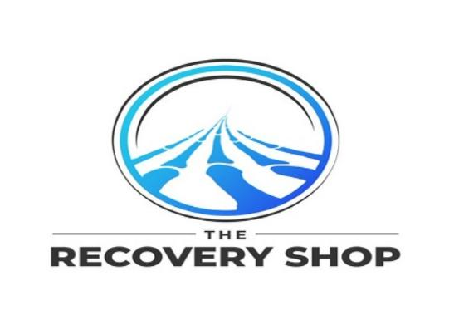

Dear Patient,

Dr. Corey Welchlin has identified a list of products to assist in your recovery following your surgery. These products can be useful as part of a protocol to help reduce pain and swelling and may improve your recovery post operatively.

These products are not covered by health insurance, and may be purchased using an HSA account or other payment method.

In order to streamline this process and ensure you are receiving products appropriate for you, we have partnered with The Recovery Shop.

**These products have been reviewed by Dr. Welchlin and are specific to your surgery. In order to purchase these products please follow these steps:**

1. Please go to https://shop-recovery.net/Welchlin

2. Review Recommended Products  
3. Select products  
4. Check Out & Pay

5. Receive products in 1-3 Business Days

Or Scan the QR Code Below:



**We recommend you purchase these products as soon as possible, so you have them immediately post-op to aid in your recovery.**

If you need assistance with your order, are unable to purchase Online, or have product related questions please feel free to contact The Recovery Shop directly:

Phone: 860.500.5020

Email: [info@shop-recovery.com](mailto:info@shop-recovery.com)

Sincerely,

Center for Specialty Care

Dr. Welchlin has a financial relationship with The Recovery Shop. Patients may select an alternative vendor. For information ask the office staff.